# Dataset Summary

This dataset contains data regarding aviation accidents from the year 1920 to 2018. The information included in the data set are as follow; date and time of the incident, place of the incident, operator of the aircraft, type of the aircraft, registration of the aircraft, total aboard (crew and passenger), crew aboard, passenger aboard, total fatalities (crew and passenger), crew fatalities, passenger fatalities and the summary of the incident. The dataset only includes aviation accidents that meets the following guild line;

* All civil and commercial aviation accidents including both scheduled and non-scheduled passenger airliners worldwide, which resulted in a fatality.
* All cargo, positioning, ferry and test flight fatal accidents.
* All military transport and military helicopter accidents with 10 or more fatalities.
* All commercial accidents with greater than 10 fatalities.
* All civil and military airship accidents involving fatalities.
* Aviation accidents involving the death of famous people.
* Aviation accidents or incidents of noteworthy interest.

# Information that can be extracted

* Year with the most aviation accident
* Region with the most crash
* Type of aircraft that often crash
* Crash with the most fatalities both crew and passenger
* Summary of selected crashes of interests

# UML Diagram

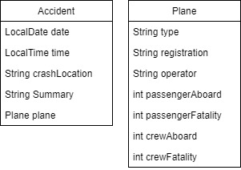

# Reference Source

All the data in this dataset are extracted from the source website at the link below

<http://www.planecrashinfo.com/database.htm>

New dataset source

<https://data.world/data-society/airplane-crashes>